Lab 04: Replication and Deduplication

Michael Johnson

CS 54D Summer

Setup the dedup Volume and the NFS Share

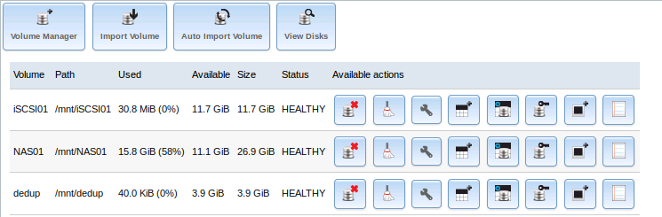

A few minutes later proof that we are dedup’ing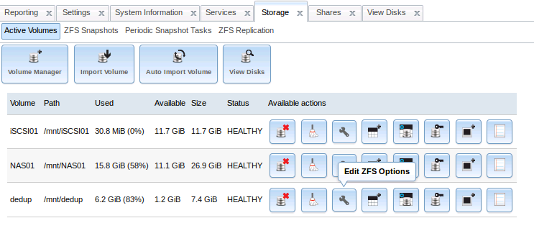

Now we Add NFS UNIX Share  
  
\*\*NOTE Typo in the Lab may read   
To access NAS02 manually, type NAS01 in the address bar and press Enter.

Ignore this

We make the directory structure we need

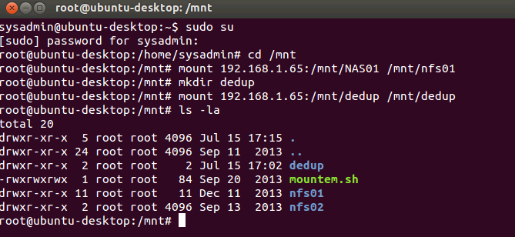

Lets see how reporting shows file duplication activity

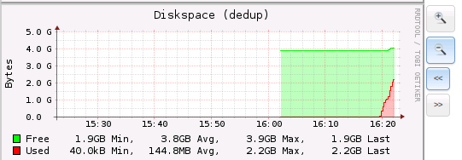

Add Snapshot

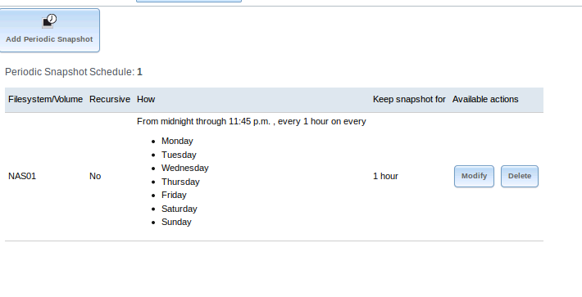

Add NAS01 root Public ssh key to root user on NAS02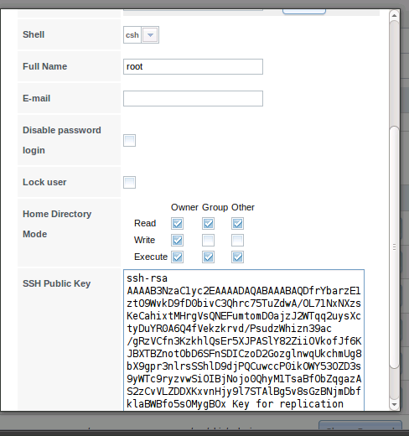

Confirmed Replication Task NAS01 🡪 NAS02

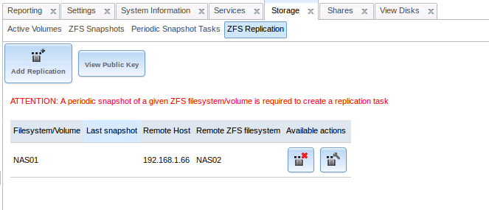

Viewing Usage during replication  
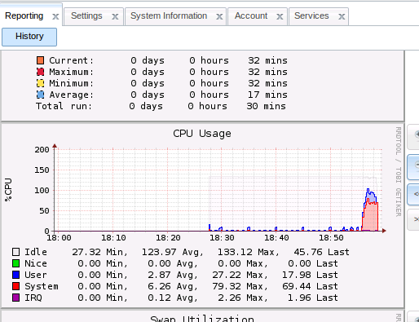

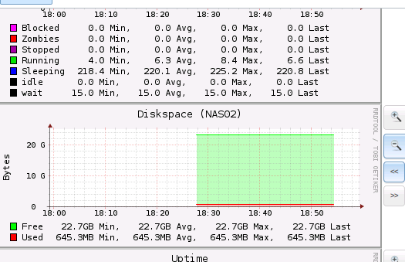

/mnt/NAS02 was empty but after the first replication task ran we now see the contents of NAS01 are now on NAS02 – Replication Successful

